电机特性示例:

MODEL 型号 | VOLTAGE 电压 |  | NO LOAD 无负荷 |  | AT MAXIMUM EFFICIENCY 最大效率点 |  |  |  |  | STALL 起动
MODEL 型号 | OPERATING RANGE 使用范围 | NOMINAL 额定值 | SPEED 转速 | CURRENT 电流 | SPEED 转速 | CURRENT 电流 | TORQUE 转矩 |  | OUTPUT 功率 | TORQUE 转矩 |  | CURRENT 电流
MODEL 型号 | OPERATING RANGE 使用范围 | NOMINAL 额定值 | r/min | A | r/min | A | mN.m | g.cm | w | mN.m | g.cm | A
PC-RF-500CAV-12560 | 4.0-7.0 | 6.0V | 2700 | 0.015 | 2214 | 0.072 | 1.08 | 11.0 | 0.25 | 6.0 | 61.2 | 0.33
PC-RF-500CAV-14415 | 4.0-7.0 | 6.0V | 3700 | 0.024 | 3090 | 0.122 | 1.71 | 17.4 | 0.470 | 10.4 | 105.7 | 0.62
PC-RF-500CAV-13510 | 6.0-12.0 | 9.0V | 4500 | 0.026 | 3706 | 0.121 | 2.22 | 22.7 | 0.670 | 12.6 | 128.6 | 0.57

其他参数：根据客户的需求设计.
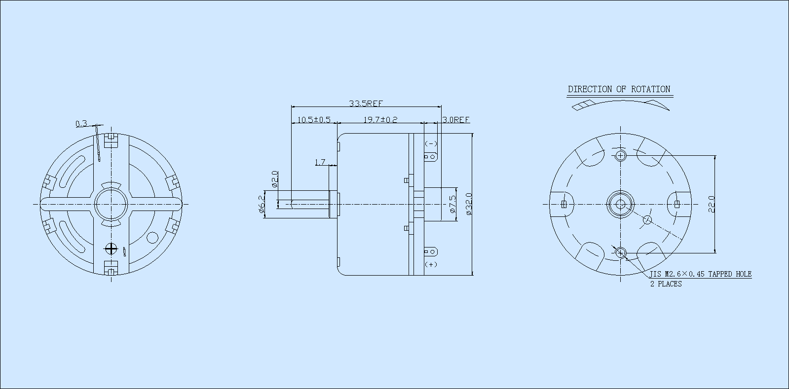

电机特性(T-N-I曲线)
